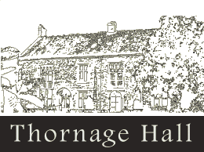

Thornage Hall Summer Fair
5th September 2021
Potential Stall holder Request Form
I would like to be considered for a stall for your Summer Fair. I understand that this is a preliminary enquiry and not a definite booking.
Contact Name
Organisation
Address
Contact email /website if relevant
Contact telephone number
Type of goods for sale (eg arts / crafts / produce)
What size space would you require?
Do you have your own table/chairs? Anything you would require us to supply if possible?

£20.00 for the stall and you keep all profits (if accepted as a stall holder, payment will be due by 1st August) – cheques made payable to Thornage Hall Independent Living
Please return this form to: Amanda Leeds, Thornage Hall, Thornage, Holt, NR25 7QH, aleeds@thornagehall.co.uk

